Flash Card Directions
  - Please use the provided flashcards to memorize the names and some general uses / facts about common igneous, metamorphic, and sedimentary rocks.
  - Write the name of the rock on the back of the flashcards. Then cut the flash cards out and try to line up the three boxes to complete each mineral.
  - Start small with only a few, get really good at those, and then add another rock into your practice. Each time you master a small set add another rock in until they are all mastered.
  - Moving the cards around on a table / clean surface is how these will help you. Just staring at them / trying to memorize them without moving and jumbling will not be as helpful.

Igneous  - Granite  - Basalt  - Obsidian  - Diorite  - Pumice  - Andesite | Sedimentary  - Conglomerate  - Shale  - Limestone  - Sandstone | Metamorphic  - Slate  - Schist  - Marble  - Quartzite

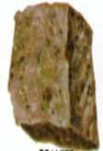 | Igneous Rock – Intrusive with large crystals. Composed mainly of quartz and feldspar. | Granite

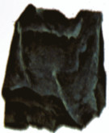 | Igneous Rock – Dark Colored. Extrusive with fine grain crystals. Forms from cooled lava. | Basalt

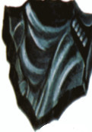 | Igneous Rock - Forms when molten rock material cools so rapidly. The result is a volcanic glass | Obsidian

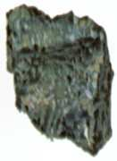 | Igneous Rock – Extrusive, A coarse-grained rock that contains a mixture of feldspar, pyroxene, hornblende and sometimes quartz. | Diorite

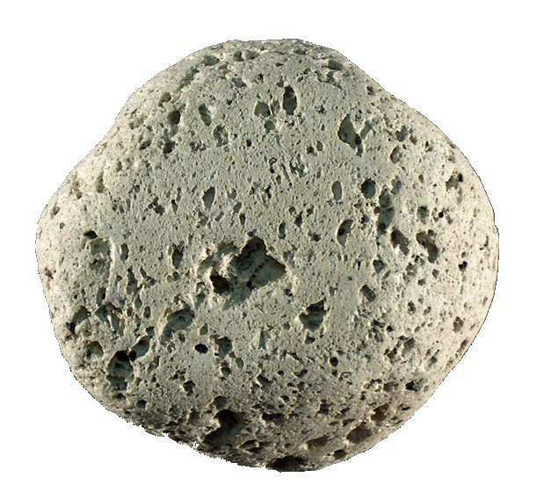 | Igneous Rock – Extrusive, A light-colored rock. It forms through very rapid cooling. | Pumice

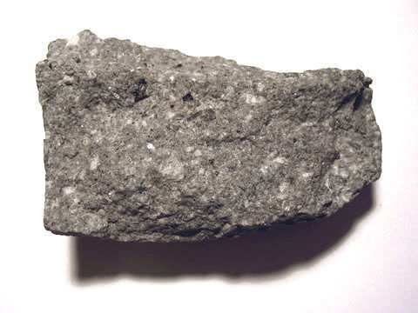 | Igneous Rock – Extrusive, A fine-grained rock composed mainly of plagioclase with other minerals such as hornblende, pyroxene and biotite. | Andesite

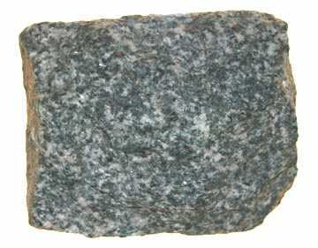 | Igneous Rock – Intrusive, Coarse-grained, dark-colored. It is usually black or dark green in color. It is the most abundant rock in the deep oceanic crust. | Gabbro

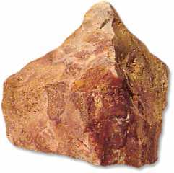 | Igneous Rock – Extrusive, a light-colored, fine-grained rock that typically contains quartz and feldspar minerals. | Rhyolite

Sedimentary Rocks
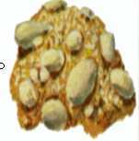 | Sedimentary, -Clastic Rock that contains large rounded clasts. The space between the clasts is generally filled with small particles that binds the rock together. | Conglomerate

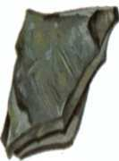 | Sedimentary, A fine-grained rock that forms from the compaction of silt and clay-size mineral particles → “Mud” | Shale

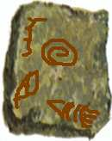 | Sedimentary - Composed primarily of calcium carbonate – (Calcite), forms in marine waters and often has fossils. | Limestone

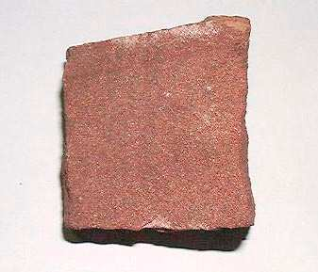 | Sedimentary, clastic rock made up mainly of sand. Found in environments where large amounts of sand can accumulate. | Sandstone

Metamorphic Rock
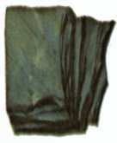 | Metamoprhic – Foliated, is fine-grained. Formed from shale and used for roofing and flooring. | Slate

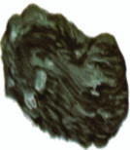 | Metamorphic – Foliated, It often contains significant amounts of mica. | Schist

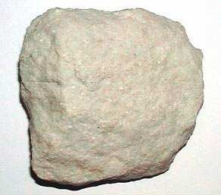 | Metamorphic, Non-foliated rock that is produced from the metamorphism of limestone. It is composed primarily of calcium carbonate. | Marble

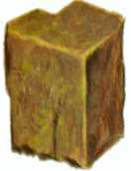 | Metamorphic, Non-foliated rock that is produced by the metamorphism of sandstone. It is composed primarily of quartz. | Quartzite

